

***#Implementation of ModelBasedVacuumAgent:***

**ABUBAKAR ASIF**

**FA20-BCE-013**

**abubakarasif3111@gmail.com**

**Artificial Intelligence**

**SUBMITTED TO:DR SHOAIB AZMAT**

***#Implementation of ModelBasedVacuumAgent:***

**#Implementation of ModelBasedVacuumAgent**

**from agents4e import \***

**from inspect import getsource**

**from utils4e import distance_squared,turn_heading**

**tve=TrivialVacuumEnvironment();**

**print("The Environment Status is:"+str(tve.status))**

**a=ModelBasedVacuumAgent()**

**tve.add_thing(a)**

**print("The Agent Location"+str(a.location))**

**tve.step()**

**print("The Environment Status is:"+str(tve.status))**

**print("The Agent Location"+str(a.location))**

**print("Coded by Abubakar Asif")**

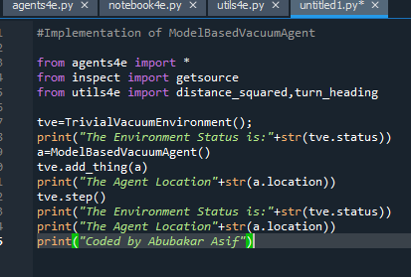

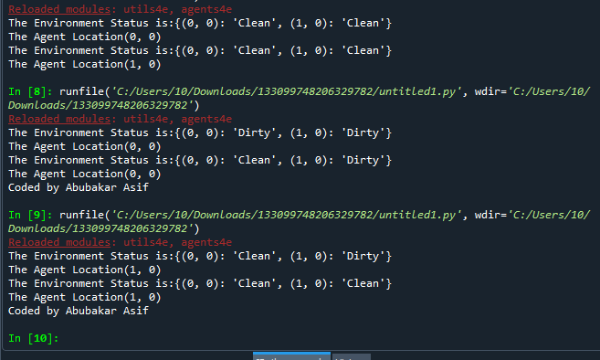

**#Implementation of TableDrivenVacuumAgent**

**from agents4e import \***

**from inspect import getsource**

**from utils4e import distance_squared,turn_heading**

**tve=TrivialVacuumEnvironment();**

**print("The Environment Status is:"+str(tve.status))**

**a=TableDrivenVacuumAgent()**

**tve.add_thing(a)**

**print("The Agent Location"+str(a.location))**

**tve.step()**

**print("The Environment Status is:"+str(tve.status))**

**print("The Agent Location"+str(a.location))**

**print("Coded by Abubakar Asif")**

